FITNESSTRACKER
CO-1 DATA TYPES AND OPERATORS
1.ABSTRACT
Abstract
The Fitness Tracker is a Java-based application developed to demonstrate the fundamental concepts of data types and operators in Java programming. The application stores basic fitness-related information such as the user's name, age, weight, and height using appropriate data types. Different data types such as String, int, and double are used according to the type of information being stored. Arithmetic operators are used to perform calculations on the given fitness data, including converting height from centimeters to meters and calculating the Body Mass Index (BMI). The program provides a simple example of how basic Java programming concepts can be applied to a real-world fitness application. This implementation helps in understanding variables, data types, arithmetic operations, and the importance of selecting suitable data types for storing and processing information.
2.ADVANTAGES
• Simple and easy to use.
• Collects basic fitness information from the user.
• Demonstrates different Java data types.
• Performs calculations using arithmetic operators.
• Calculates BMI quickly and accurately.
• Helps understand the practical use of Java programming concepts.
3.IMPLEMENTATION
The Fitness Tracker is implemented using Java programming language. The program uses the Scanner class to accept the user's name, age, weight, and height as input. Different data types such as String, int, and double are used to store the information. Arithmetic operators are used to convert height from centimeters to meters and calculate the user's BMI.
The BMI is calculated using the formula:
BMI = Weight / (Height × Height)
where weight is measured in kilograms and height is measured in meters.
CODE:
public class Main {
public static void main(String[] args) {

String name = "Sai";
int age = 18;
double weight = 70;
double height = 70;

double heightMeter = height / 100;
double bmi = weight / (heightMeter * heightMeter);

System.out.println("===== FITNESS TRACKER =====");
System.out.println("Name: " + name);
System.out.println("Age: " + age);
System.out.println("Weight: " + weight + " kg");
System.out.println("Height: " + height + " cm");
System.out.println("BMI: " + bmi);
}
}
OUTPUT:
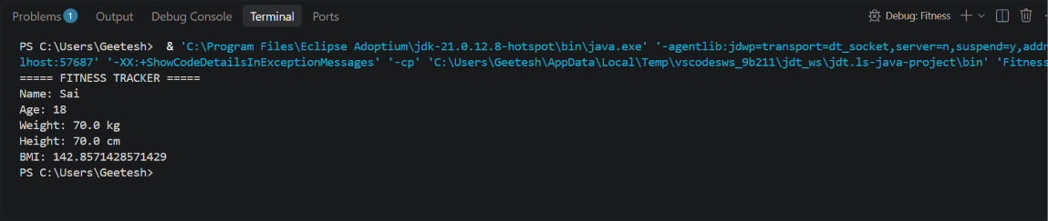
4.CONCLUSION
The CO1 Fitness Tracker program successfully demonstrates the use of Java data types and operators. The program stores the user's name, age, weight, and height using appropriate data types and performs arithmetic operations to calculate BMI. This implementation provides a basic understanding of how Java concepts can be applied to a real-world fitness application.
CO2 – If-Else Ladder, Switch Case and Loops.
1.ABSTRACT
Abstract
The Fitness Tracker is a Java-based application developed to demonstrate the use of control statements such as if-else ladder, switch case, and loops. These control statements help the program make decisions and perform repeated operations based on fitness-related information. The if-else ladder is used to determine the fitness status according to the number of steps completed by the user. The switch case is used to select different exercise activities such as walking, running, and cycling. A for loop is used to display fitness information for multiple days without writing the same statements repeatedly. The project demonstrates how decision-making and repetition can be implemented in Java to create simple and organized fitness applications. It also helps in understanding program flow and the practical use of control statements.

2.ADVANTAGES
• Helps make decisions based on fitness data.
• Provides different fitness results using if-else statements.
• Allows the user to select an exercise using switch case.
• Loops can display multiple days of fitness data.
• Reduces repetitive code.
• Makes the Fitness Tracker more interactive and organized.
3.IMPLEMENTATION
The Fitness Tracker is implemented using Java control statements. An if-else ladder is used to determine the user's fitness status based on the number of steps completed. A switch case is used to select an exercise activity. A for loop is used to display the step count for multiple days. These control statements help the program make decisions and perform repeated operations.
IF ELSE
public class Main {
public static void main(String[] args) {

int steps = 8500;

System.out.println("===== FITNESS TRACKER =====");
System.out.println("Steps: " + steps);

if (steps >= 10000) {
System.out.println("Fitness Status: Excellent");
} else if (steps >= 7500) {
System.out.println("Fitness Status: Good");
} else if (steps >= 5000) {
System.out.println("Fitness Status: Average");
} else {
System.out.println("Fitness Status: Need More Activity");
}
}
}
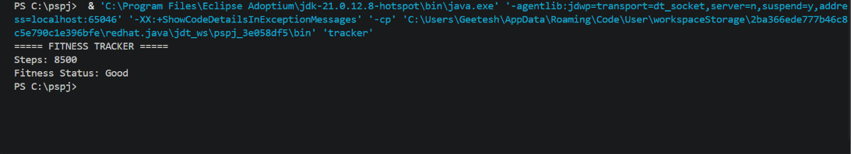
SWITCH CASE
public class Main {
public static void main(String[] args) {

int choice = 2;

System.out.println("===== FITNESS TRACKER =====");
System.out.println("Exercise Choice: " + choice);

switch (choice) {
case 1:
System.out.println("Exercise: Walking");
break;

case 2:
System.out.println("Exercise: Running");
break;

case 3:
System.out.println("Exercise: Cycling");
break;

default:
System.out.println("Invalid Exercise");
}
}
}
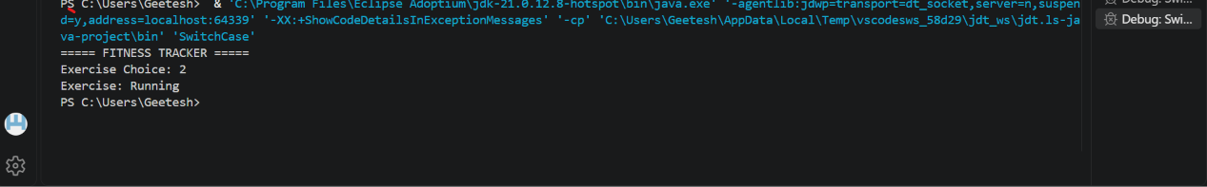
FOR LOOP
public class Main {
public static void main(String[] args) {

int steps = 8500;

System.out.println("===== FITNESS TRACKER =====");

for (int day = 1; day <= 5; day++) {
System.out.println("Day " + day + ": " + steps + " steps");
}
}
}
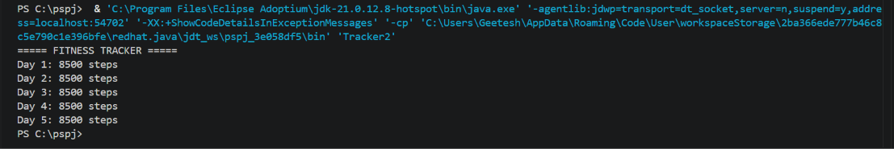
4.CONCLUSION
The CO2 Fitness Tracker programs successfully demonstrate the use of Java control statements. The if-else ladder is used for decision-making, the switch case is used to select an exercise, and the for loop is used to repeat a set of instructions. These concepts help in developing simple and organized Java programs for real-world fitness applications.
CO3 – METHODS, 1D ARRAY AND 2D ARRAY
1.ABSTRACT

The Fitness Tracker is a Java-based application developed to demonstrate methods, one-dimensional arrays, and two-dimensional arrays. These concepts are useful for creating structured programs and managing multiple fitness-related values efficiently. Methods are used to create reusable blocks of code for performing specific operations, which improves code organization and reduces repetition. A one-dimensional array is used to store fitness data such as the number of steps completed on different days. A two-dimensional array is used to store multiple types of fitness information, such as daily steps and calories burned, in rows and columns. The project demonstrates how Java methods and arrays can be used to organize, store, and process fitness information. It also provides practical understanding of code reusability, data storage, looping, and structured programming.
2.ADVANTAGES
- Makes the program easier to understand and organize.
- Methods allow code to be reused multiple times.
- 1D arrays store multiple fitness values efficiently.
- 2D arrays store data in rows and columns.
- Reduces repeated code.
- Helps manage and process fitness data easily.
3.IMPLEMENTATION
- The Fitness Tracker is implemented using Java methods and arrays. A method is created and called to perform a specific fitness calculation. A one-dimensional array is used to store fitness data for multiple days. A two-dimensional array is used to store different fitness details in rows and columns. These concepts make the program simple, reusable, and organized.
METHODS
public class Main {

static int totalSteps(int morning, int evening) {
return morning + evening;
}

public static void main(String[] args) {

int morningSteps = 4000;
int eveningSteps = 4500;

int total = totalSteps(morningSteps, eveningSteps);

System.out.println("===== FITNESS TRACKER =====");
System.out.println("Morning Steps: " + morningSteps);
System.out.println("Evening Steps: " + eveningSteps);
System.out.println("Total Steps: " + total);
}
}
OUTPUT
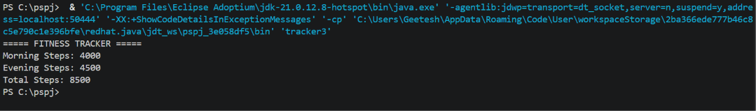
1D ARRAY
public class Main {
public static void main(String[] args) {

int[] steps = {8000, 9000, 7500, 10000, 8500};

System.out.println("===== FITNESS TRACKER =====");

for (int i = 0; i < steps.length; i++) {
System.out.println("Day " + (i + 1) + ": " + steps[i] + " steps");
}
}
}
OUTPUT
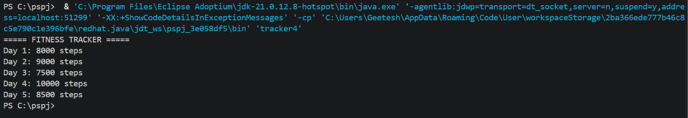
2D ARRAY
public class Main {
public static void main(String[] args) {

int[][] fitness = {
{8000, 300},
{9000, 350},
{7500, 280},
{10000, 400},
{8500, 320}
};

System.out.println("===== FITNESS TRACKER =====");

for (int i = 0; i < fitness.length; i++) {
System.out.println("Day " + (i + 1)
+ " - Steps: " + fitness[i][0]
+ ", Calories: " + fitness[i][1]);
}
}
}
OUTPUT
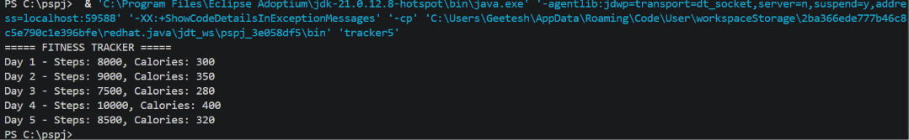
CONCLUSION:
The CO3 implementation of the Personal Fitness and Workout Tracker successfully demonstrates the use of methods, one-dimensional arrays, and two-dimensional arrays in Java. Methods are used to create and call reusable blocks of code for fitness calculations, while a one-dimensional array stores fitness data for different days. A two-dimensional array organizes multiple fitness details, such as daily steps and calories burned, in rows and columns. These concepts help in organizing, storing, and processing personal fitness and workout information efficiently and provide a practical understanding of structured Java programming.

